Fall 2016
Somatic Wellness Workshop Series
Prepare Your Body & Mind for the Winter Season

The Immune System - Saturday, October 22nd, 2pm to 4:30pm - Studio C
The Stress Response - Sunday, October 23rd, 11am to 1:30pm - Studio D
At BAX Brooklyn Arts Exchange (421 5th Ave. @ 8th St. 11215)
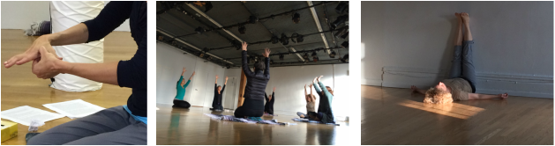
​
​Learn how to support and strengthen your immune system and stress response from the inside out, using breath, sound, movement, touch and food! This workshop is part of a Somatic Wellness Series with registered Somatic Movement Therapists and Dynamic Embodiment practitioners Dana Davison and Mandy Sau Yi Chan, where we explore the related body systems, integrating practices from Body-Mind Centering®, Laban/Bartenieff Studies, Yoga and Traditional Chinese Medicine. Come and treat yourself to more effective and efficient self-protection and deep relaxation!
Cost: $50 each or $90 for both
Cost: $25 - To repeat the workshop if you have taken it before with us.
For register and Information,click here.

