​​Spring 2016
*Somatic Movement Workshops
taught by Mandy Sau Yi Chan and Dana Davision
Registered Somatic Movement Therapists and Certified DE Practitioners

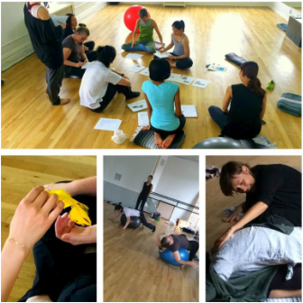

​

​​
Introduction to Bartenieff Fundamentals
SUNDAY, Jan. 31st, 9-11am.
SUNDAYS, Feb. 4th & 21st, 9-12pm.
SUNDAY, Apr. 3rd, 2-4:30pm
Sections:
Jan. 31st Mobility/Stability - Basic 6 & Movement Themes
Feb.14th Function/Expression - Bio/History & Principles 1
Feb. 21st Exertion/recuperation - Principles 2 & Relational Concepts
Apr. 3rd Inner/Outer - Application/Lab/Review
Introduction to Developmental Movement
SATURDAY, Feb. 20th, 9-12pm
SATURDAY, Mar. 26th, 9-1pm & 3-6pm
Sections:
Feb. 20th Introduction to Embryology From Cells to Pre-Birth
Mar 26th Yield-Push-Reach-Pull
From Newborn to One-Year-Old (9am-11am)
Adult Forms
Limb Relationships & Integration (11am-1pm)
Application and Review (3pm-6pm)
Workshops will be held at BAX - Brooklyn Arts Exchange (421 5 Ave at 8th Street in Park Slope NY 11215) and can be taken individually for $350, or by sections for prorated fee. For more information and to register, please email Mandy@breathingheart.com
*These workshops are sponsored by Moving for Life, and qualify as prerequisites for Dr. Martha Eddy's Moving for Life and BodyMind Dancing somatic dance teacher training.
Founded by Dr. Martha Eddy in 1991, Dynamic Embodiment (DE) uniquely synthesizes Body-Mind Centering®, Bartenieff Fundamentals and Laban Movement Analysis, creating an integrated, multidimensional methodology for experiencing the body from within.

